**Requirements Analysis Document**

* 1. Problem Description
* Handmade flash cards are great but can cause be inconvenient at times. A student can spend so much time writing down flashcards for several different classes and sometimes do not have the time to study them.
* Once the student has finished the class that they made the flashcards for then the flash cards will no longer be used or wasted.
* Other flash card applications do not offer the feature to allow hint or difficulty levels.
* Some flash card apps also do not have a testing option that keeps track of the users score and time spent while going through a set of cards.
  1. Vision
* Students have used flash cards as a study tool for many years, and our vision is to create an app that is convenient for students of all grade levels.
* Students can create flashcards at the touch of their fingertips on any handheld device. The cards made can be saved to a library on their app.
* We want to allow our users to have access to the flashcards of other users so that there is no waste. Users will be able to download flashcards in the app and can save them to their libraries.
* Flash Card Mania will allow users to seek hints and change the difficulty level of each set of flashcards.
* We will offer the option of learning which will allow the user to study the flash cards and then a testing option that allows them to test their knowledge of the cards and keep track of the time spent.
  1. Business Case
* Flashcards can be used as a great study tool for students who are focused on learning more about a specific subject. Flash Card Mania can help students to gaining knowledge and exercise academic skills at the same time.
  1. Feature List
* Option to view hints
* Ability to change difficulty level
* Share cards with others
* Change background
* Progress report
  1. Example Systems

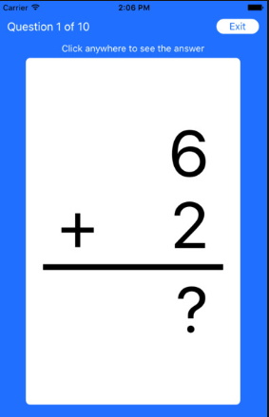

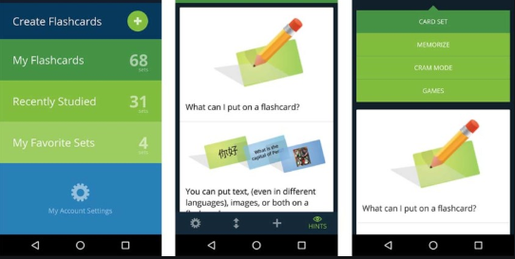

2.1 Functional Statements that can’t be expressed in use cases: a function list

* Create flashcards
* View libraries and cards
* Edit or delete libraries and cards
* Study flashcards
* Test flashcards
* Timer setting

2.2 URPS+

* **Usability** – Flash Card Mania is suited for users of all ages. Flash cards can be easily used. The app allows the card to be used as physical flashcards. One side is the questions and a simple tap on the card will reveal the answer.
* **Reliability** – All flashcards can be downloaded onto the device, so users can use the app without internet connection.
* **Performance** – The flash card app allows for great performance and all functions are easy to navigate and perform.
* **Supportability** – The game will be a Java application that will run only on mobile devices. This game will run on android systems. In order to maintain our app, we will update and make changes based on the client’s need.
* +
* **Implementation** – we will be using Android Studio to implement the flash card app.
* **Interface** – unknown/NA
* **Operations** – The application will be available at all times.
* **Packaging** - We will use a zip file to package our application.
* **Legal** – We will site all our outside resources to prevent copyright infringement.

2.3 Scenarios + Use cases

* **Brief:**
  + **Use Case Name**: Study with Flash Card Mania
  + **Actors**: User
  + The user opens the app and an intro screen will appear. Once it was disappeared, the user will view a menu displaying the following: my libraries, study, and test.

The user may select my libraries to view, edit, or create libraries and flashcards. Studying can be used to study a set of flashcards and testing can be used to test the user’s knowledge with a set of flashcards. The user will be allowed to track studying time and can receive hint and change the difficulty level before starting the flashcards. In testing, the user can view the progress they have made from previous test runs.

* **Casual:**
* **Use Case Name**: Study with Flash Card Mania
* **Actors**: User
  + **Main success scenario**: The user opens the app and an intro screen will appear. Once it was disappeared, the user will view a menu displaying the following: my libraries, study, and test. The user may select my libraries to view, edit, or create libraries and flashcards. Studying can be used to study a set of flashcards and testing can be used to test the user’s knowledge with a set of flashcards. The user will be allowed to track studying time and can receive hint and change the difficulty level before starting the flashcards. In testing, the user can view the progress they have made from previous test runs.
* **User selects my libraries:** The user can access any saved flashcards, and edit, delete, create, or add cards.
* **User selects studying:** The users can study a set of flashcards. The users can change the difficulty settings, set a study time, and has the option to allow hints.
* **User select testing:** User wants to test their knowledge. Here the user can test a set of flashcards by selecting which set. The testing option allows the user to test how well they know the cards and allows for them to see the progress they have made with each round of testing.
* **Fully Dressed:**
* **Primary Actor**: The User
* **Scope**: Program
* **Three levels** - Easy, Moderate, Hard - are described to the player
* **Main Flow**:

1. Player opens Flash Card Mania
2. Intro/Splash screen appears
3. Menu appears
4. Player selects an option
   1. Player selects My Libraries

4.1.1. Display all libraries.

4.1.2. User can edit, delete, create new libraries and cards

4.1.3. If “+” button selected user can create a new library

4.1.4. User can create card

4.1.5. Add question and answer

4.1.6. Option to set difficulty level and hints

* 1. Player selects Studying
     1. User can study flash cards
     2. Select difficulty, set timer, and hint option
     3. Press start
     4. First card appears
     5. Tap on card to flip card and reveal answer
     6. Swipe for next card
  2. Player selects Testing
     1. User can test flash cards
     2. Select difficulty level or hint option
     3. Press start
     4. First card appears
     5. Tap to flip card and revel answer
     6. Swipe for next card
     7. End testing
     8. View results
* **Alternative flows**:

1a. If program cannot be run on the app, an error message will notify the player

2a. A reminder error message will appear on several pages of the app as the user is using the app. This will assure that they have an understanding that there is an error in the application

* **Post conditions**:
  + User has the option to study more cards when finished studying
  + User has the option to view results when finished testing
* **Special requirements**:
  + User must input text or an image for the question of a flashcard

2.4 Domain Model, Object Diagrams

* **Use Case Diagram**:

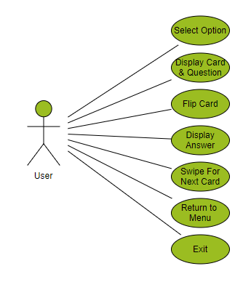

* **Object Diagram**:

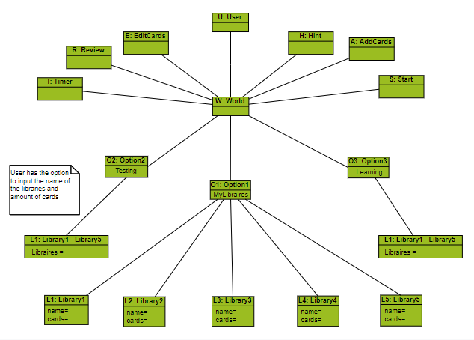

2.5 SSDs, Operation Contracts

* **System Sequence Diagram**:

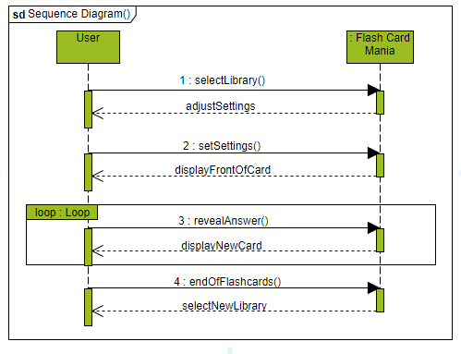

2.6 State Diagrams

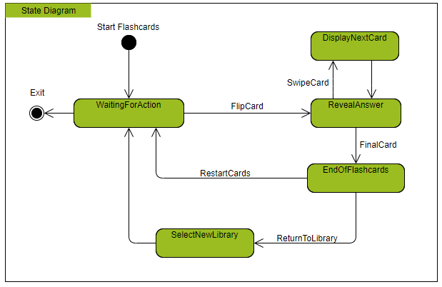

* 1. UI, Mock Ups, UML Activity Diagrams, “Web” Navigation Frames
* **UI**:

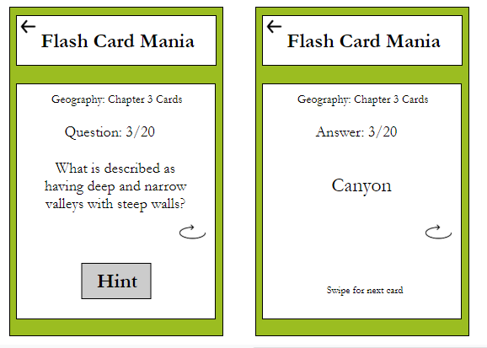

* **Web Navigation Frame**: HTML

3. Glossary: N/A